**WAD ASSIGNMENT**

Name: Rutuja Dipak Thakare.

Subject: Web Development and Application Assignment.

Q 1. Illustrate the Need of a Nodemailer Package ?

Ans: The nodemailer package is a popular module in the Node.js ecosystem that allows you to send emails programmatically. It serves as a crucial tool for various applications and scenarios where email communication is essential. Here are a few reasons that illustrate the need for a nodemailer package:

* Email Notifications: Many applications require the ability to send email notifications to users. This could include account verification emails, password reset requests, order confirmations, newsletters, and more. The nodemailer package provides a convenient and straightforward way to send such notifications directly from your Node.js application.
* Contact Forms: Websites often have contact forms that allow users to send messages or inquiries. When a user submits a form, the nodemailer package can be used to process the form data and send an email to the desired recipient. This enables effective communication between website visitors and the website owners.
* Transactional Emails: Transactional emails are messages sent to users based on specific actions or events, such as account activation, order updates, or delivery notifications. The nodemailer package allows you to automate the sending of these emails, making it easy to integrate them into your application's workflows.
* Email Marketing: If you are developing an email marketing system or integrating email marketing capabilities into your application, the nodemailer package can be invaluable. It enables you to send bulk emails to your subscribers, manage email templates, personalize messages, and track the delivery status.
* Testing and Development: During the development and testing phase of an application, it is often necessary to simulate email sending without actually sending emails to real recipients. The nodemailer package provides a "test" mode that allows you to capture the email output, making it easier to verify and debug email-related functionality.
* Customization and Integration: Nodemailer is highly customizable and supports various email service providers (ESPs) like Gmail, Outlook, SendGrid, Mailgun, and more. It provides a consistent API for sending emails, regardless of the underlying email service provider you choose. This flexibility allows you to integrate nodemailer seamlessly into your existing application infrastructure.

Q 2 . Implement small application which will make use of mentioned package (I/p, O/p)

Ans:

use the nodemailer package we have to install it using

**npm install nodemailer**

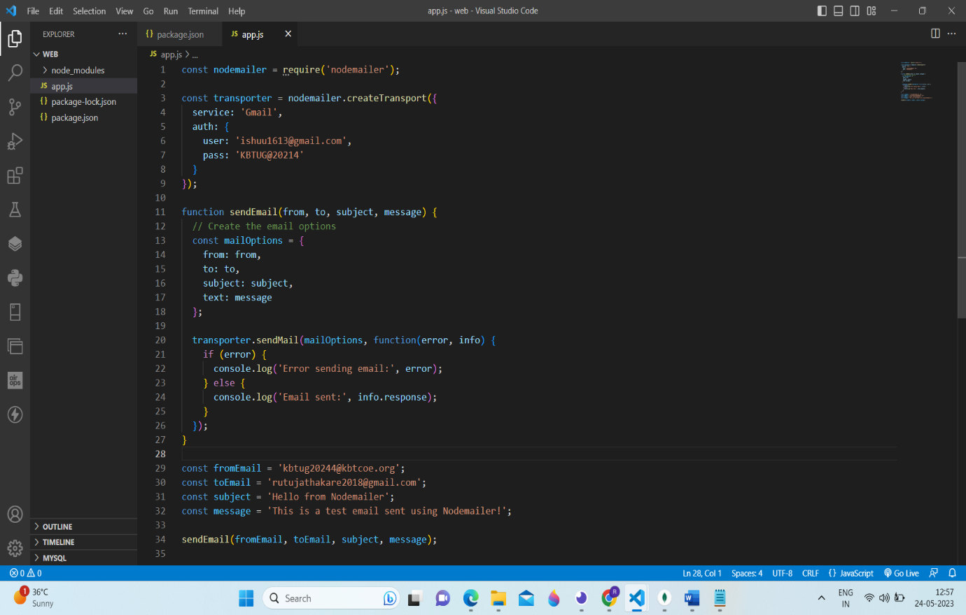

Q 3. Illustrate the need for code of ethics.

Ans: Here are some key reasons illustrating the need for a code of ethics for Nodemailer:

* Privacy and Data Protection: Nodemailer handles sensitive user data, including email addresses, messages, and attachments. A code of ethics ensures that this data is treated with the utmost care and confidentiality, protecting user privacy and complying with relevant data protection regulations.
* Responsible Use of Nodemailer: The code of ethics establishes guidelines for the responsible use of Nodemailer, preventing its misuse for spamming, phishing, or any other malicious activities. It promotes ethical email marketing practices, such as obtaining proper consent, providing clear opt-out mechanisms, and respecting recipients' preferences.
* Legal Compliance: Nodemailer operates within a legal framework, and a code of ethics helps ensure compliance with applicable laws, regulations, and industry standards. It sets clear expectations for users to abide by copyright laws, intellectual property rights, anti-spam regulations, and other legal requirements related to email communication.
* Respect for Recipients: The code of ethics emphasizes respect for the recipients of emails sent through Nodemailer. It discourages deceptive practices, misleading subject lines, or any behavior that may cause harm, discomfort, or inconvenience to recipients. It promotes transparency and honesty in email communications.
* Anti-Discrimination and Inclusivity: The code of ethics promotes equality and inclusivity by discouraging the use of Nodemailer for discriminatory or offensive purposes. It encourages users to avoid sending emails that contain hate speech, discriminatory content, or any form of harassment, ensuring a respectful and inclusive email ecosystem